THE MOON

CHARACTERISTICS
DIAMETER - 3476 km (~ 1/4 Earth)

PERIOD OF ROTATION - 27.3 days

PERIOD OF REVOLUTION - 27.3 days
i.e. The same side of the Moon always faces the Earth.

GRAVITY - 1/6 Earth

ATMOSPHERE - none (gravity is so low that any gas molecules have escaped).

SURFACE TEMPERATURES - 123 °C in the sun, -233 °C in the shade.

ORBIT - nearly circular and 384,400 km from Earth.

OTHER CHARACTERISTICS - it reflects sunlight and does not produce any light of its own.

As the Moon has no atmosphere, the surface is unprotected from cosmic rays, meteorites and solar winds, and has huge temperature variations. The lack of atmosphere means no sound can be heard on the Moon, and the sky always appears black.

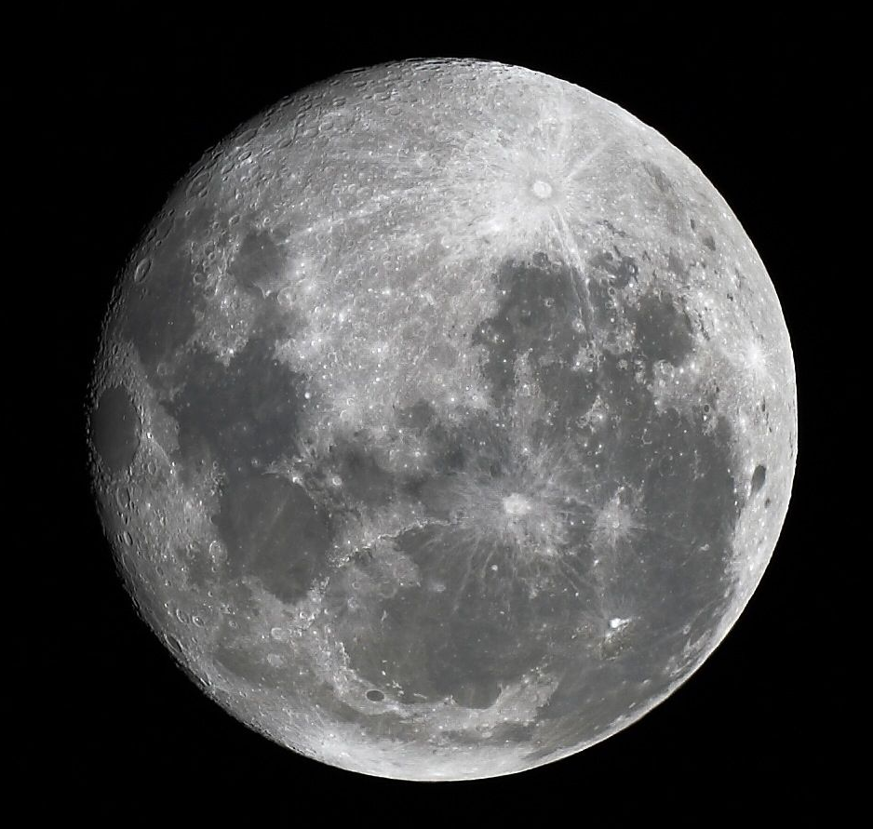
SURFACE
The surface has several features.

MARIA - flat, dark areas that look like “seas”.

HIGHLANDS - lighter coloured and rough mountainous areas.

CRATERS - some with flat bottoms like maria, others with rough bottoms and mountain peaks in the middle.

RILLES - long, narrow valleys.

Most craters appear to have been made by meteor impacts but some seem to be of volcanic origin. The absence of an atmosphere means that no weathering of rocks occurs, resulting in the mountains being much more massive than those on Earth. Our mountains here have eroded away over millions of years.

PHASES
These occur over a 29.5-day period and are due to the changing position of the Moon relative to the Earth and Sun.

The phases appear as follows from Earth.

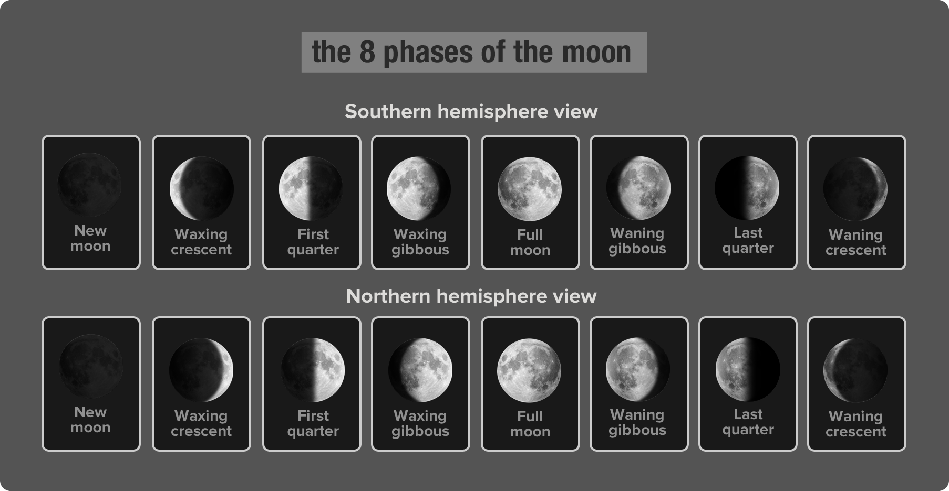

The relative position of the Earth, Moon and Sun are shown in the following diagram.

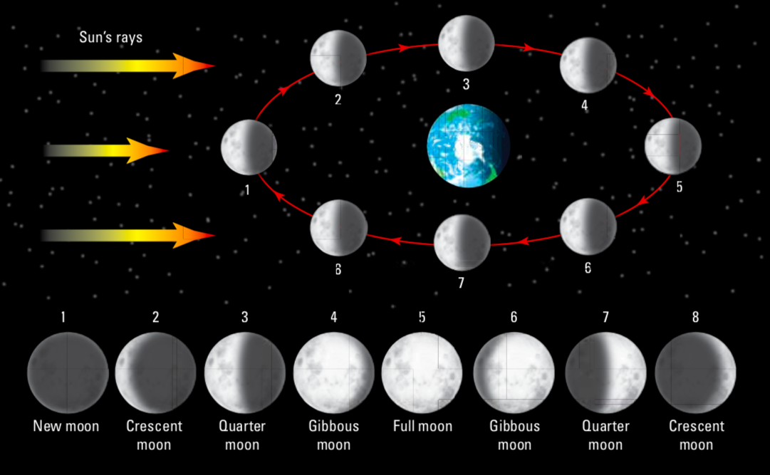

The Moon can only be seen by the sunlight reflected from it - it does not produce its own light. Hence the term “moonlight” is incorrect - it is really sunlight!

ECLIPSES
Periodically, the Earth, Moon and Sun line up. Depending on the position of the Moon, this leads to a lunar or solar eclipse. (Lunar eclipses occur far more frequently.)

SOLAR ECLIPSE - The Moon passes between the Earth and the Sun, throwing a shadow onto the Earth.

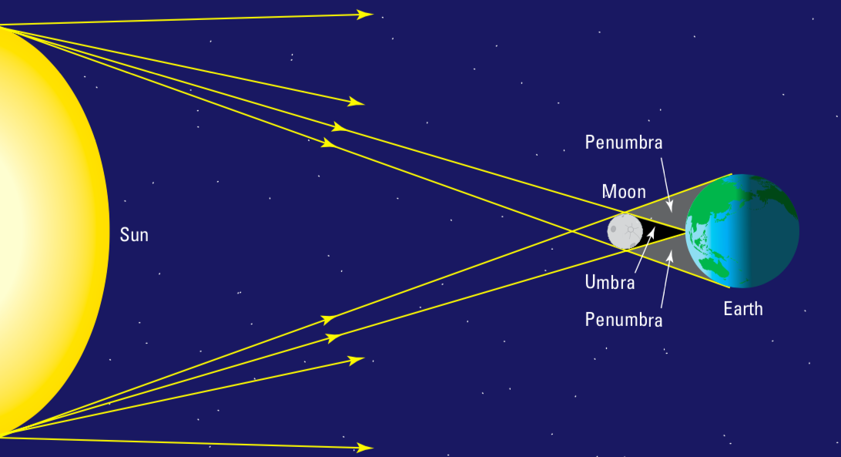

During a solar eclipse, the Moon nearly covers the disk of the Sun, allowing astronomers to observe the corona in detail. This can only happen from the small area of the Earth covered by the total shadow.

LUNAR ECLIPSE - The Moon passes into the shadow of the Earth.

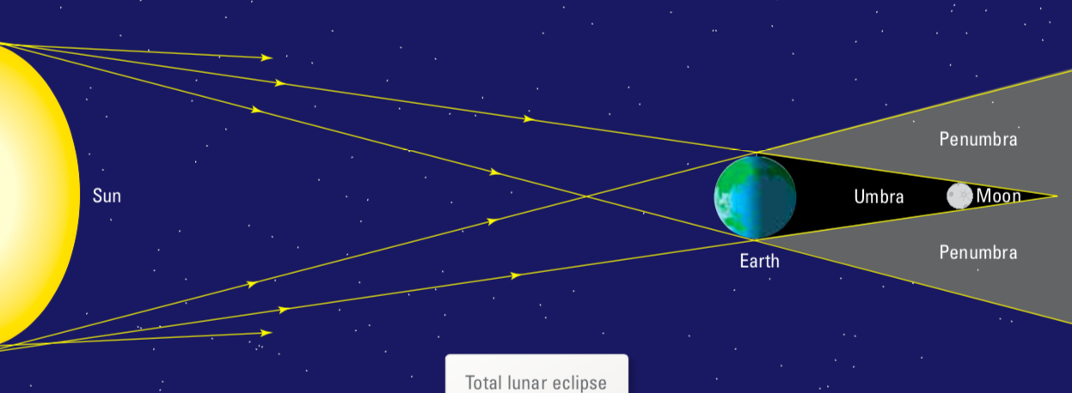
TIDES
The Moon, being relatively close to the Earth, attracts the water in the oceans with a force due to gravity. When the Moon is directly overhead, there is a high tide on that side of the Earth and a high tide on the opposite side (where the Earth has been attracted away from the surface). Between these two points is where the low tide occurs.

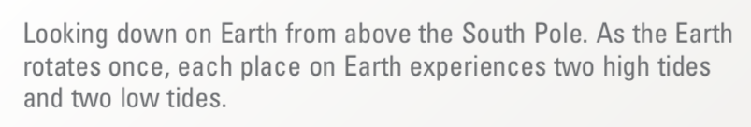
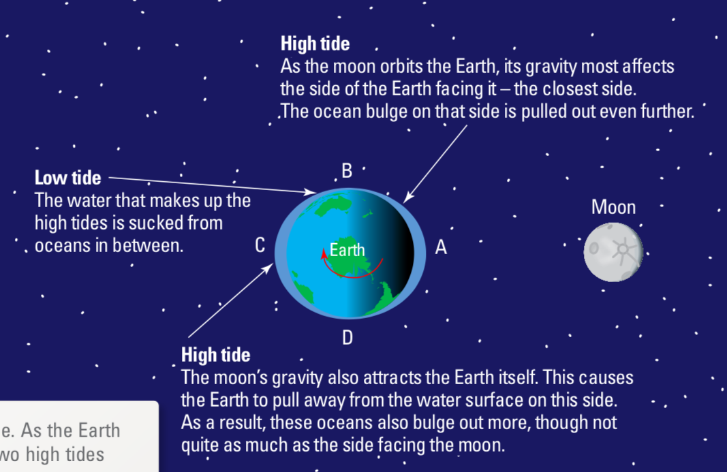

Each place on the Earth experiences two high tides and two low tides per day. Given that the Moon appears to take about 25 hours to revolve around the Earth once, the high tides occur about 12.5 hours apart.

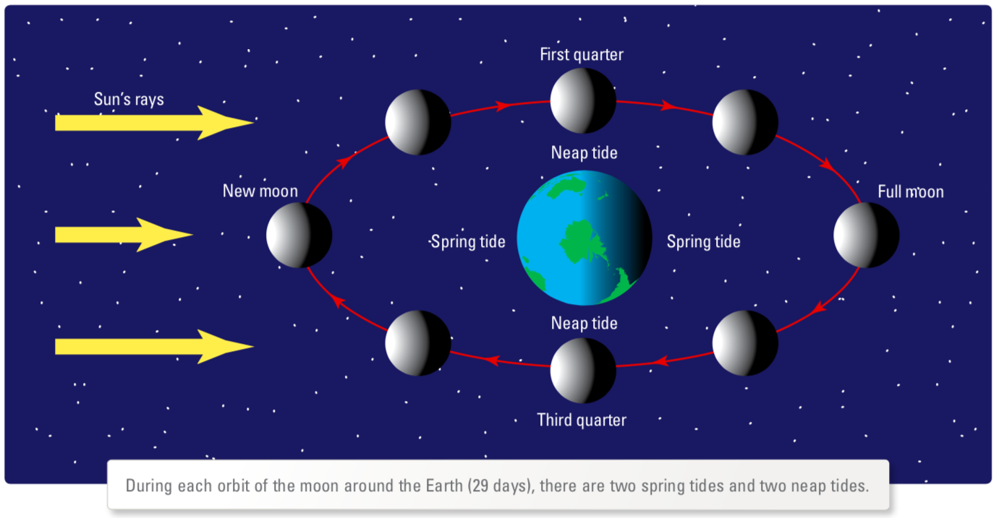
The Sun can also influence the tides, though its effect is much smaller since it is much further from the Earth.

During a full moon or a new moon (when the Sun, Moon and Earth are all in a line) the high tides are larger than usual. These are called king or spring tides. They occur during a new or full moon.

When the Sun is at right angles to the Earth and the Moon, it results in smaller high tides (called neap tides). These occur during the first and third quarters. The pull of the Sun partly negates the pull of the Moon.

